Week in Review - February 22-March 1
Alex Shvartsman

GRAND PRIX BOSTON
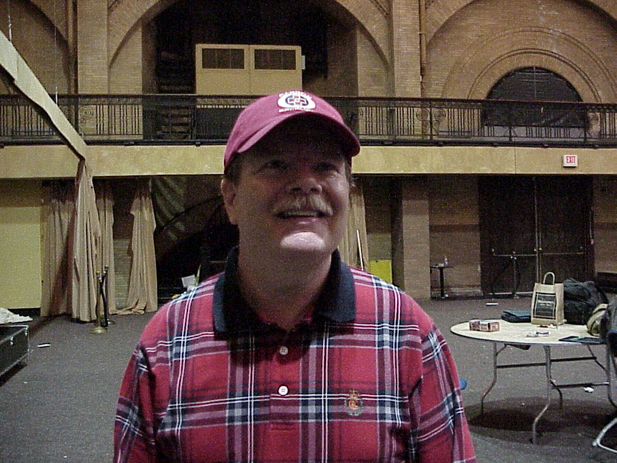
Tom Swan, a fifty year old resident of Pennsylvania, who has several Pro Tour appearances under his belt, but no resume finishes, surprised everyone by remaining in the lead of the standings throughout the weekend, and taking the first place.
Finishing second place was Mindripper editor Scott Johns. Johns finally broke his Grand Prix curse last year, and has put in several impressive performances, keeping ahead of his Potato Nation teammates in the Player of the Year race. He is now in the fourth place at 45 Pro Tour points, on the heels of Kai Budde at 47, who failed to pick up any points in Cologne this weekend.
Alan Comer, 3rd place finisher, needed a strong performance to get back on the Pro Tour. This veteran from San Diego has been dedicating most of his time to work, and just recently fell off the "gravy train." Four Pro Tour points and an invitation to Barcelona will go a long way toward getting him back on.
Matt Vienneau, who won Grand Prix Dallas, proves that his slump is over, and his Dallas performance was not a fluke, with another Top 4 finish. Canada is the only other country to win some Top 8 slots in US Grand Prix.
A member of team AlphaBetaUnlimited, Brian Hegstad is playing his first ever Pro Tour season - and his Grand Prix performances are placing him highly in the Rookie of the Year race. Hegstad achieved two 11th place finishes in Dallas and New Orleans - he followed them up with a fourth place finish in Boston.
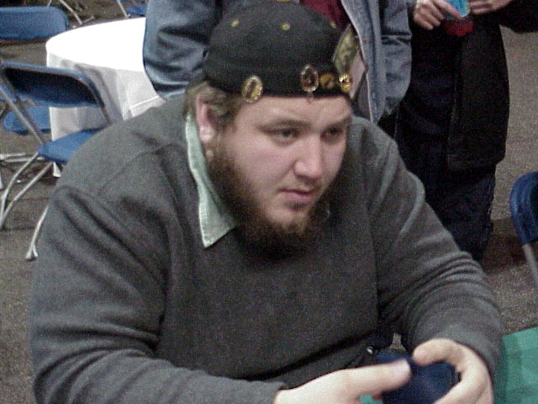
Kurtis Hahn is best known for creating the "5-Color" format that has been increasingly popular over the last year. In Boston, you could see matchups like Randy Buehler vs. Bob Maher, playing this cool format. Each 5-color game is for cut ante, and Maher managed to cut to Buehler's Mox Ruby. I never did learn whether Buehler was able to win the match and keep his Mox. This is the first time Hahn finished highly in a title tournament, and Barcelona will be his first Pro Tour.
Kyle Rose followed his Top 8 finish in Los Angeles with a Top 8 finish in Boston. He is still pretty far from the top of the Player of the Year race, but Rose can never be counted out.
Finally, Chris Benafel added another Top 8 to his belt. Along with teammates Noah Boeken and Ryan Fuller, Benafel has been dominating the Grand Prix circuit this season. At 26 points, he is currently 14th in the race - one strong PT performance away from real contention.
A few pros traveled from afar to compete here. Britain's Warren Marsh chose to come to Boston, rather than take a much shorter trip to GP Cologne. His reason? "I came for the weather," explained the sarcastic Englishman.
Marsh is responsible for the weirdest moment of the tournament. He greeted Gary Wise, who was drafting at the time (not in the tournament), by sneaking up behind him and... licking the top of his head! The incident and both its participants were a target of many jokes throughout the weekend - most of them originated from Gary himself.

GRAND PRIX COLOGNE

German Jim Herold joins an elite group of three-time Grand Prix winners. His first major tournament success was winning Grand Prix: Oslo last season. His team than won Grand Prix: Frankfurt. He has now repeated on home turf. The only other players to win three Grand Prix are Kai Budde, Jon Finkel, and Steve O'Mahoney Schwartz. Budde is the only one to win three individual Grand Prix.
The Ruel brothers are also continuing their dominance of the European Grand Prix circuit. Olivier barely missed the Top 8, finishing ninth. His brother Antoine finished second.
Trey Van Cleave, who moved to Denmark a while back, snagged a third place finish, followed by Joost Vollebregt from Holland.
Between the two tournaments, this was the largest Grand Prix weekend ever, with over 500 competitors playing in each of the two tournaments. Boston became the largest North American Grand Prix, edging out D.C. and Philadelphia.

EARTHQUAKE FOR SEVEN

Work at Wizards of the Coast headquarters in Renton, WA and other places in the Seattle area was interrupted this Wednesday afternoon by a 6.8 earthquake. 6.8 is relatively high on the Richter scale - fortunately though no one at the office was hurt. They did close the building for inspection and some minor repairs, and reopened today.
Experts say that Earthquakes of such ferocity in the Northwest are "restricted" to one every three hundred years or so - so if you are in Seattle area around year 2300, bring a CoP: Red.

PLAYTESTING FOR TOKYO
With the next Constructed Pro Tour less than a month away, most teams have been stabilized. Although some of the team membership lists are murky, here are several of the high profile groups that have been set up for this event:
Team Zvi (not sure what name they end up using this time):
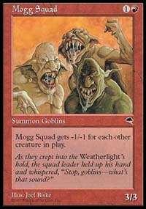
Zvi Mowshowitz, Scott Johns, Seth Burn, Kai Budde, Brian Selden, Patrick Mello, Warren Marsh, Ben Ronaldson
Mogg Squad has gone through some changes over the last several Pro Tours, dropping a number of its original members. Their attempted merger with Cabal Rogue (Adrian Sullivan, etc.) did not work out for either party. For this event, Squad members teamed up with some of the higher profile members of former European Alliance. Will this new group work out in the end? I guess we'll know after Tokyo.
New European Alliance?
Chris Benafel, Ryan Fuller, Noah Boeken, Kamiel Cornelissen, Raphael Levy, Antoine and Olivier Ruel
Members of Team AlphaBetaUnlimited teamed up with the Dutch and the French to create a new European powerhouse. Is this group mismatched, or can it work well together? I heard that some of them have not even begun testing the format yet, as of last weekend, while many of the major teams are working out the kinks from their sideboards by now. Either way, this is probably the most interesting group to watch in Tokyo. With many of its members capable of jumping into or within a very short striking distance of the Pro Tour race lead with a PT win, they should be motivated to work very hard.
Team Rejects
Alex Shvartsman, Brian Davis, Mattias Jorstedt, Mattias Kettil, Jakub Slemr, Trevy Van Cleave, and Mike Pustilnik and Marc Paschover as consultants.
Most of us ended up left behind after various mergers/splits of teams Mogg Squad and EA - thus the name. Our group was one of the more successful in Chicago, with almost everyone who played our deck (including Norwegians Eskeland and Herzog) finishing in the money. Was our success a fluke, or can we sufficiently prepare for Tokyo despite lacking a deckbuilding superstar like Mowhowitz or Ronaldson? We'll see.
A number of other interesting groups are forming, such as a group of Scandinavian players working together, innovative deckbuilder Eric Taylor forming a team of his own, Team Neutral Ground with over ten people helping out several of the store's regulars who are qualified, and several others. Established teams like YMG and CMU are quietly working on the format as well.
Next week, I am going to take a look at the teams competing in the Masters Series and the Masters Gateway. If your team plans on competing in the Gateway, please let me know so I can mention it in the article.

MAGIC TRIVIA
Last week's question:
You only play one creature in an entire game. Your opponent has absolutely no defensive measures, so he takes full damage from the creature every time you attack with it. Assuming nothing is done to alter the creature's power, the damage dealt, or your opponent's life total, and that it is the only source of damage against your opponent that you play, what creature deals game-winning (at least 20) combat damage in exactly eight turns after it is played?
Answer:
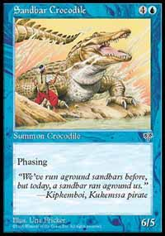
Sandbar Crocodile. Turn 1: cast it. Turn 2: phases. Turn 3: Attack for 6. Turn 4: phases. Turn 5: attack for 6 (12 total). Turn 6: phases. Turn 7: attack for 6 (18 total). Turn 8: phases. Turn 9: Win.
New Question:
How many Scryb Sprites does it take to kill a first-striking Sengir Vampire in combat?
Please do not e-mail me with your answers. There is no prize, this is strictly for fun. Correct answer will be posted in the next week's column.

BEST OF THE NET
You think Magic Haiku are funny? How about Magic limericks?
Meridian Magic's own Cathy Nicoloff posted a cute contest, where Magic players were called upon to complete a limerick that begins with the line "There Once Was a Player of Magic." Literally hundreds of people played, including the names you know like Randy Buehler, Zvi Mowshowitz and Scott Johns. Some of the best entries and the results are showcased here.

PLAY OF THE WEEK
Courtesy of Pete Hills
This took place during the Extended PTQ season. My teammate Chris was playing a Full English Breakfast deck against a Sliver deck.
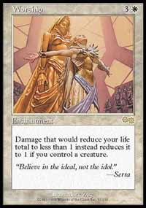
In the third game vs. Slivers, the Sliver player was able to get a Worship in to play. So, when Chris attacked with the Shapeshifter, the Sliver player didn't block, thinking he was safe from lethal damage. Chris did the normal trick, Surviving for Hellion, activating it 10 times, then in response Surviving for Phyrexian Dreadnought, placing 20+ points of damage on the stack. This is where it gets good; once damage was on the stack Chris used a Quirion Ranger to untap the Shifter/Nought, Survived for an Elvish Lyrist, and sacrificed the Shifter/Lyrist (still hasted because of the Hellion ability) to destroy the Worship. The stack resolved, Chris won the game, and made one of the best plays I've ever been a witness to.

BAD PLAY OF THE WEEK
Courtesy of Chris "Better Lucky Than Good" Cade:
My opponent had no creatures on the board, and was at two life. I had a flier on the board that would kill him next turn. At the end of my turn, he cast Repulse on it, and I responded by sacrificing the flier to Death Bomb (targeting itself) to make him lose his last two life points... not realizing that Death Bomb says "that player" instead of "target player." End result: I tapped 4 mana, discarded a black removal spell, and sacrificed a creature to counter his Repulse. Fortunately I didn't have to lose 2 life since the Death Bomb was countered upon resolution.
As always, please send good/bad plays, cool trivia questions, and other news to ashv@concentric.net.

